Problem-1

1. Update the portfolio and feedback forms using Bootstrap CDN

Code: portfolio3.html

<!DOCTYPE html>

<html lang="en">

<head>

<meta charset="UTF-8">

<meta name="viewport" content="width=device-width, initial-scale=1.0">

<title>Portfolio</title>

<link href="https://cdn.jsdelivr.net/npm/bootstrap@5.3.3/dist/css/bootstrap.min.css" rel="stylesheet" integrity="sha384-QWTKZyjpPEjISv5WaRU9OFeRpok6YctnYmDr5pNlyT2bRjXh0JMhjY6hW+ALEwIH" crossorigin="anonymous">

</head>

<body>

<header class="bg-dark text-white text-center py-3">

<h1>Welcome to My Portfolio</h1>

</header>

<div class="container mt-4">

<section id="introduction" class="card p-4 mb-3">

<h2>Self Introduction</h2>

<p>Hello! My name is Mohammed ObaidUllah. I am a passionate Web Developer. I love working on innovative projects and learning new skills.</p>

</section>

<section id="skills" class="card p-4 mb-3">

<h2>Skills</h2>

<ul>

<li>Programming Languages: C, C++, Python, Java.</li>

<li>Web Development: HTML, CSS, JavaScript, Bootstrap.</li>

<li>Database Management: MySQL, MongoDB.</li>

<li>Other Skills: Problem Solving, Team Collaboration.</li>

</ul>

</section>

<section id="projects" class="card p-4 mb-3">

<h2>Projects / Work Experiences</h2>

<ul>

<li><a href="#">Personal Portfolio Website</a> - Designed and developed a responsive portfolio website using HTML, CSS, and JavaScript.</li>

<li><a href="#">Task Management App</a> - Built a full-stack web application to manage daily tasks using MongoDB, Express.js, and Node.js.</li>

<li><a href="#">E-commerce Platform</a> - Created a simple e-commerce platform for small businesses using React and Firebase.</li>

<li><a href="#">Weather App</a> - Developed a weather application that displays real-time weather data using the OpenWeatherMap API.</li>

</ul>

</section>

<section id="feedback" class="card p-4 mb-3">

<h2>Feedback / Achievements</h2>

<ul>

<li>Awarded "Best Innovative Project" for the Task Management App during Marathon 151.</li>

<li>Successfully completed a professional certification in Python.</li>

<li>Received excellent feedback from clients for developing user-friendly and robust applications.</li>

</ul>

</section>

<section id="education" class="card p-4 mb-3">

<h2>Education Profile</h2>

<ul>

<li><strong>Keshav Memorial Institute of Technology</strong> - B. Tech in Computer Science and Engineering (CGPA: 8.85/10)</li>

<li><strong>MS Junior College</strong> - 11-12 SSC: 940/1000</li>

<li><strong>Ravindra Bharathi School</strong> - SSC (GPA: 9/10)</li>

</ul>

</section>

<section id="contact" class="card p-4 mb-3">

<h2>Contact Information</h2>

<p>Email: <a href="mailto:mohammedobaidullah2004@gmail.com">mohammedobaidullah2004@gmail.com</a></p>

<p>Phone: <a href="tel:+9391307881">+9391307881</a></p>

<p>Social Media:

<ul>

<li><a href="#">LinkedIn</a></li>

<li><a href="#">Twitter</a></li>

<li><a href="#">GitHub</a></li>

</ul>

</p>

</section>

</div>

<script src="https://cdn.jsdelivr.net/npm/bootstrap@5.3.3/dist/js/bootstrap.bundle.min.js" integrity="sha384-YvpcrYf0tY3lHB60NNkmXc5s9fDVZLESaAA55NDzOxhy9GkcIdslK1eN7N6jIeHz" crossorigin="anonymous"></script>

</body>

</html>

Output:

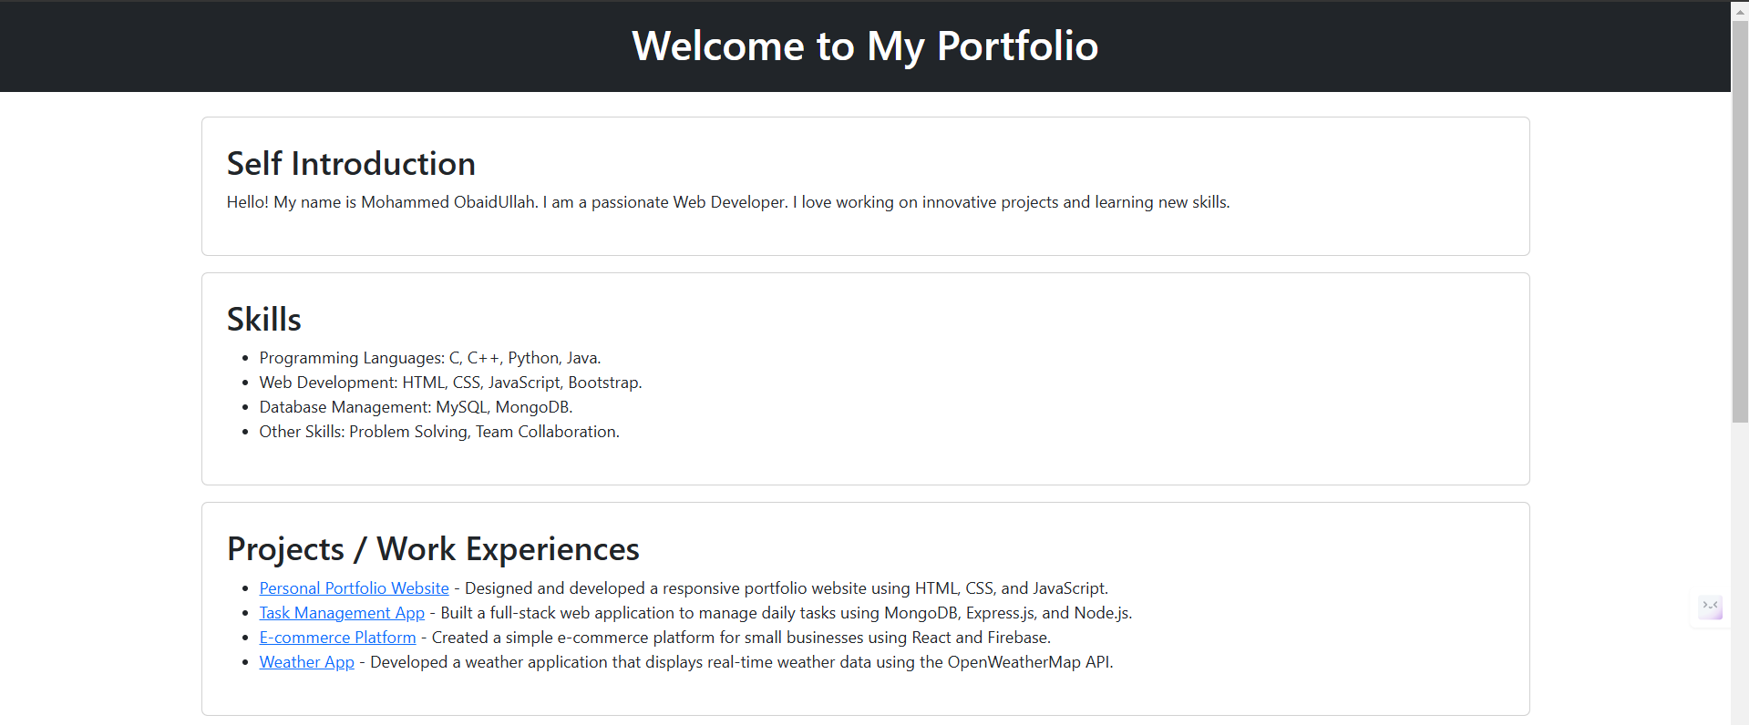

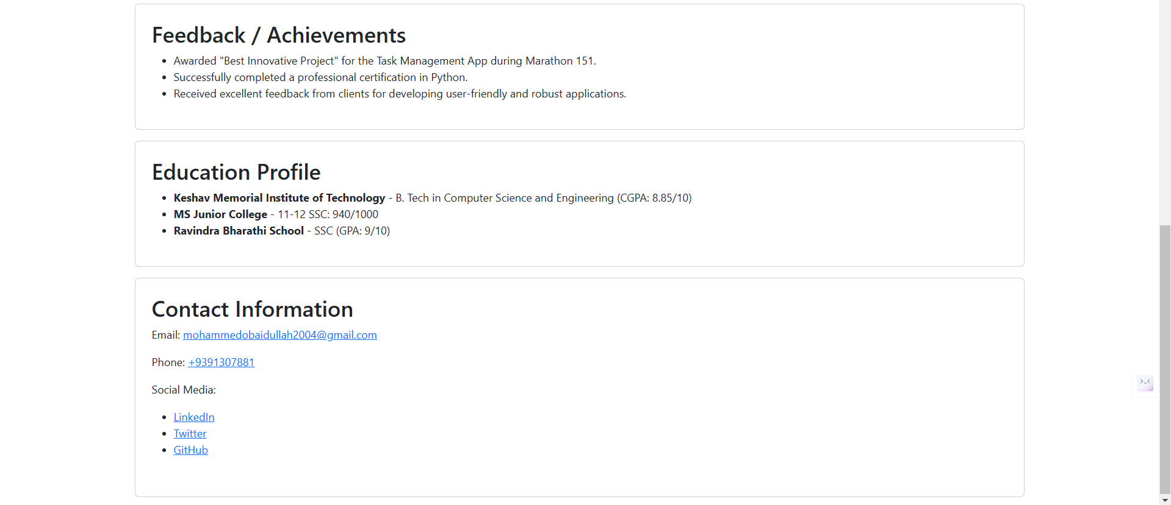

Github link: <https://github.com/MohammedObaidUllah/FEWD/blob/main/portfolio3.html>

Code: feedback3.html

<!DOCTYPE html>

<html lang="en">

<head>

<meta charset="UTF-8">

<meta name="viewport" content="width=device-width, initial-scale=1.0">

<title>Feedback Form</title>

<link href="https://cdn.jsdelivr.net/npm/bootstrap@5.3.3/dist/css/bootstrap.min.css" rel="stylesheet" integrity="sha384-QWTKZyjpPEjISv5WaRU9OFeRpok6YctnYmDr5pNlyT2bRjXh0JMhjY6hW+ALEwIH" crossorigin="anonymous">

</head>

<body>

<header class="bg-dark text-white text-center py-3">

<h1>Feedback Form</h1>

</header>

<section class="container mt-4">

<div class="card p-4">

<form action="submit_feedback.php" method="post">

<div class="mb-3">

<label for="name" class="form-label">Name (Optional):</label>

<input type="text" id="name" name="name" class="form-control">

</div>

<div class="mb-3">

<label for="email" class="form-label">Email (Optional):</label>

<input type="email" id="email" name="email" class="form-control">

</div>

<div class="mb-3">

<label for="phone" class="form-label">Phone (Optional):</label>

<input type="tel" id="phone" name="phone" class="form-control">

</div>

<div class="mb-3">

<label for="rating" class="form-label">Rating:</label>

<select id="rating" name="rating" class="form-select" required>

<option value="">Select</option>

<option value="1">1</option>

<option value="2">2</option>

<option value="3">3</option>

<option value="4">4</option>

<option value="5">5</option>

</select>

</div>

<div class="mb-3">

<label for="questions" class="form-label">Any Questions Regarding Product or Service:</label>

<textarea id="questions" name="questions" class="form-control" required></textarea>

</div>

<div class="mb-3">

<label for="comments" class="form-label">Additional Comments (Optional):</label>

<textarea id="comments" name="comments" class="form-control"></textarea>

</div>

<button type="submit" class="btn btn-primary">Submit</button>

</form>

</div>

</section>

<script src="https://cdn.jsdelivr.net/npm/bootstrap@5.3.3/dist/js/bootstrap.bundle.min.js" integrity="sha384-YvpcrYf0tY3lHB60NNkmXc5s9fDVZLESaAA55NDzOxhy9GkcIdslK1eN7N6jIeHz" crossorigin="anonymous"></script>

</body>

</html>

Output:

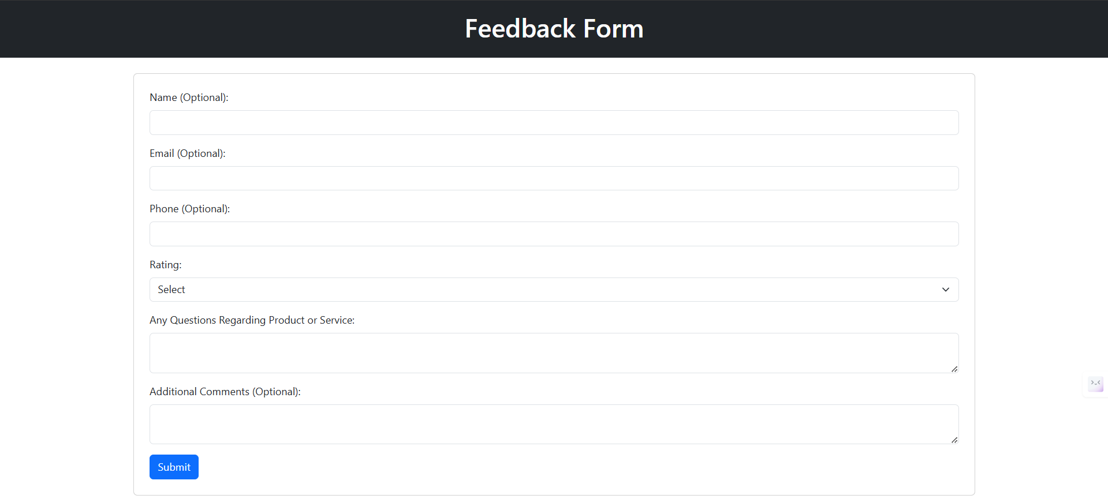

Github link: <https://github.com/MohammedObaidUllah/FEWD/blob/main/feedback3.html>

Problem-2

Update the portfolio and feedback forms using downloaded Bootstrap files

Downloaded BootStrap files:

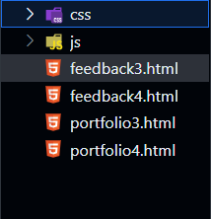

Code: portfolio4.html

<!DOCTYPE html>

<html lang="en">

<head>

<meta charset="UTF-8">

<meta name="viewport" content="width=device-width, initial-scale=1.0">

<title>Portfolio</title>

<link href="css/bootstrap.min.css" rel="stylesheet">

</head>

<body>

<header class="bg-dark text-white text-center py-3">

<h1>Welcome to My Portfolio</h1>

</header>

<div class="container mt-4">

<section id="introduction" class="card p-4 mb-3">

<h2>Self Introduction</h2>

<p>Hello! My name is Mohammed ObaidUllah. I am a passionate Web Developer. I love working on innovative projects and learning new skills.</p>

</section>

<section id="skills" class="card p-4 mb-3">

<h2>Skills</h2>

<ul>

<li>Programming Languages: C, C++, Python, Java.</li>

<li>Web Development: HTML, CSS, JavaScript, Bootstrap.</li>

<li>Database Management: MySQL, MongoDB.</li>

<li>Other Skills: Problem Solving, Team Collaboration.</li>

</ul>

</section>

<section id="projects" class="card p-4 mb-3">

<h2>Projects / Work Experiences</h2>

<ul>

<li><a href="#">Personal Portfolio Website</a> - Designed and developed a responsive portfolio website using HTML, CSS, and JavaScript.</li>

<li><a href="#">Task Management App</a> - Built a full-stack web application to manage daily tasks using MongoDB, Express.js, and Node.js.</li>

<li><a href="#">E-commerce Platform</a> - Created a simple e-commerce platform for small businesses using React and Firebase.</li>

<li><a href="#">Weather App</a> - Developed a weather application that displays real-time weather data using the OpenWeatherMap API.</li>

</ul>

</section>

<section id="feedback" class="card p-4 mb-3">

<h2>Feedback / Achievements</h2>

<ul>

<li>Awarded "Best Innovative Project" for the Task Management App during Marathon 151.</li>

<li>Successfully completed a professional certification in Python.</li>

<li>Received excellent feedback from clients for developing user-friendly and robust applications.</li>

</ul>

</section>

<section id="education" class="card p-4 mb-3">

<h2>Education Profile</h2>

<ul>

<li><strong>Keshav Memorial Institute of Technology</strong> - B. Tech in Computer Science and Engineering (CGPA: 8.85/10)</li>

<li><strong>MS Junior College</strong> - 11-12 SSC: 940/1000</li>

<li><strong>Ravindra Bharathi School</strong> - SSC (GPA: 9/10)</li>

</ul>

</section>

<section id="contact" class="card p-4 mb-3">

<h2>Contact Information</h2>

<p>Email: <a href="mailto:mohammedobaidullah2004@gmail.com">mohammedobaidullah2004@gmail.com</a></p>

<p>Phone: <a href="tel:+9391307881">+9391307881</a></p>

<p>Social Media:

<ul>

<li><a href="#">LinkedIn</a></li>

<li><a href="#">Twitter</a></li>

<li><a href="#">GitHub</a></li>

</ul>

</p>

</section>

</div>

<script src="js/bootstrap.bundle.min.js" ></script>

</body>

</html>

Output:

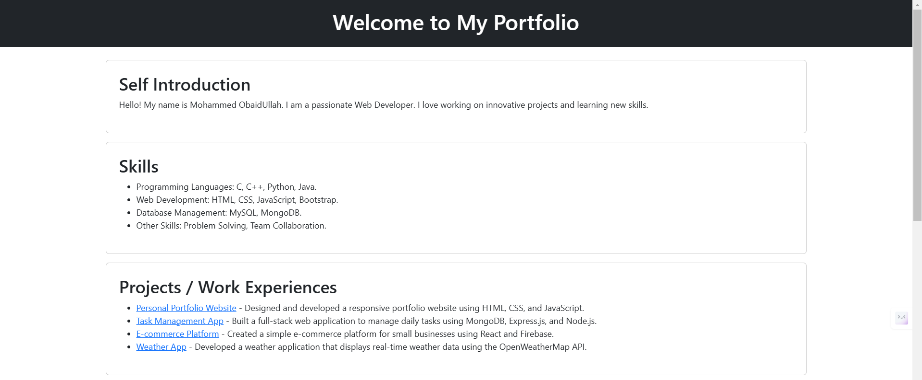

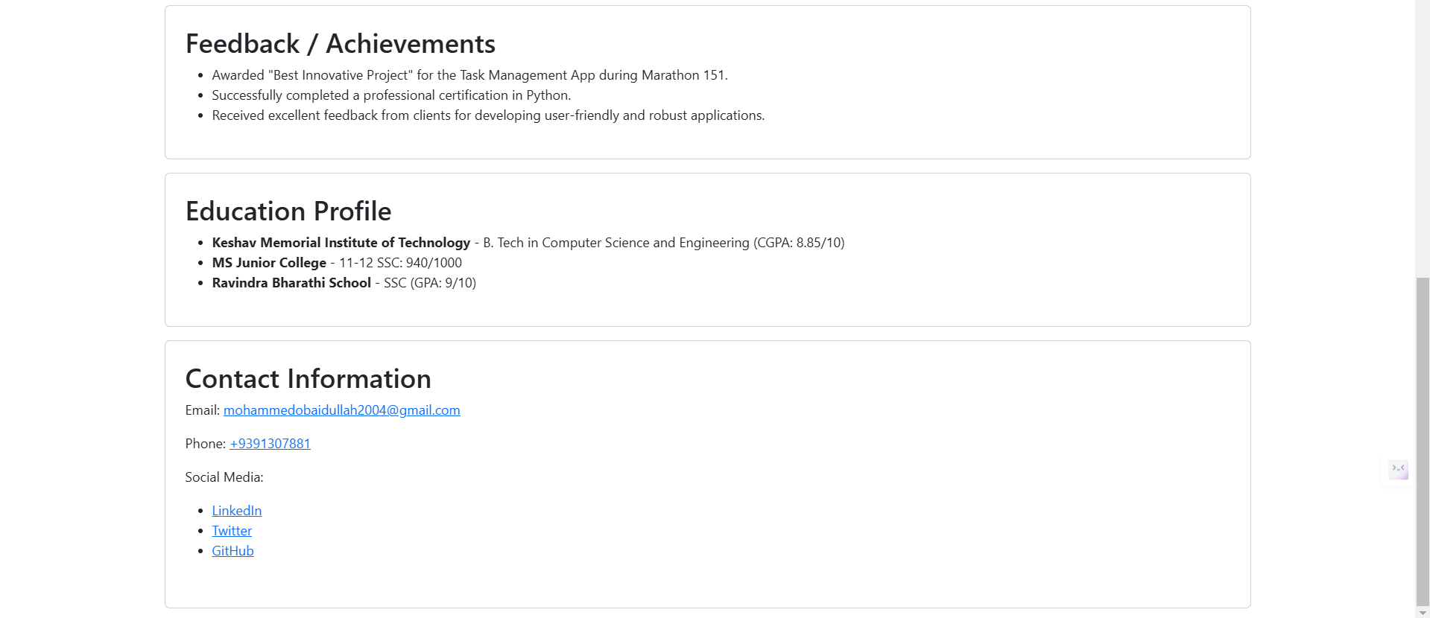

Github link: <https://github.com/MohammedObaidUllah/FEWD/blob/main/portfolio4.html>

Code: feedback4.html

<!DOCTYPE html>

<html lang="en">

<head>

<meta charset="UTF-8">

<meta name="viewport" content="width=device-width, initial-scale=1.0">

<title>Feedback Form</title>

<link href="css/bootstrap.min.css" rel="stylesheet">

</head>

<body>

<header class="bg-dark text-white text-center py-3">

<h1>Feedback Form</h1>

</header>

<section class="container mt-4">

<div class="card p-4">

<form action="submit_feedback.php" method="post">

<div class="mb-3">

<label for="name" class="form-label">Name (Optional):</label>

<input type="text" id="name" name="name" class="form-control">

</div>

<div class="mb-3">

<label for="email" class="form-label">Email (Optional):</label>

<input type="email" id="email" name="email" class="form-control">

</div>

<div class="mb-3">

<label for="phone" class="form-label">Phone (Optional):</label>

<input type="tel" id="phone" name="phone" class="form-control">

</div>

<div class="mb-3">

<label for="rating" class="form-label">Rating:</label>

<select id="rating" name="rating" class="form-select" required>

<option value="">Select</option>

<option value="1">1</option>

<option value="2">2</option>

<option value="3">3</option>

<option value="4">4</option>

<option value="5">5</option>

</select>

</div>

<div class="mb-3">

<label for="questions" class="form-label">Any Questions Regarding Product or Service:</label>

<textarea id="questions" name="questions" class="form-control" required></textarea>

</div>

<div class="mb-3">

<label for="comments" class="form-label">Additional Comments (Optional):</label>

<textarea id="comments" name="comments" class="form-control"></textarea>

</div>

<button type="submit" class="btn btn-primary">Submit</button>

</form>

</div>

</section>

<script src="js/bootstrap.bundle.min.js" ></script>

</body>

</html>

Output:

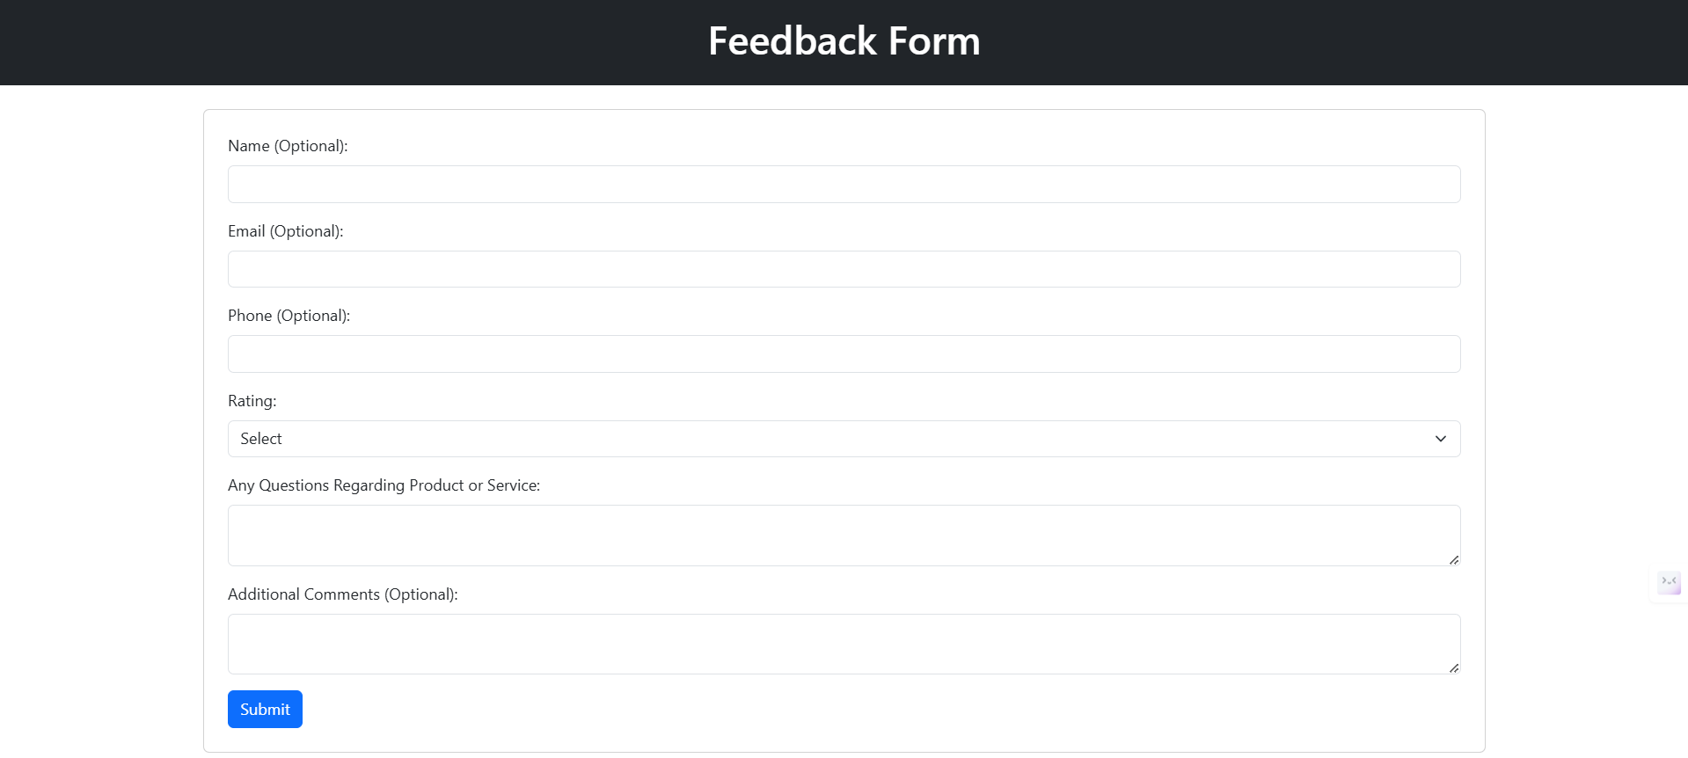

Github link: <https://github.com/MohammedObaidUllah/FEWD/blob/main/feedback4.html>